1998 C5 Corvette PCM / ECM circuit board w Corroded Diode > Needs Replacement. (ECM Part #’s 19332289 (and 16238212.)
ALSO Compatible with 98 Camaro and 98 Firebird

The red tube “points” to the UNlabeled Diode

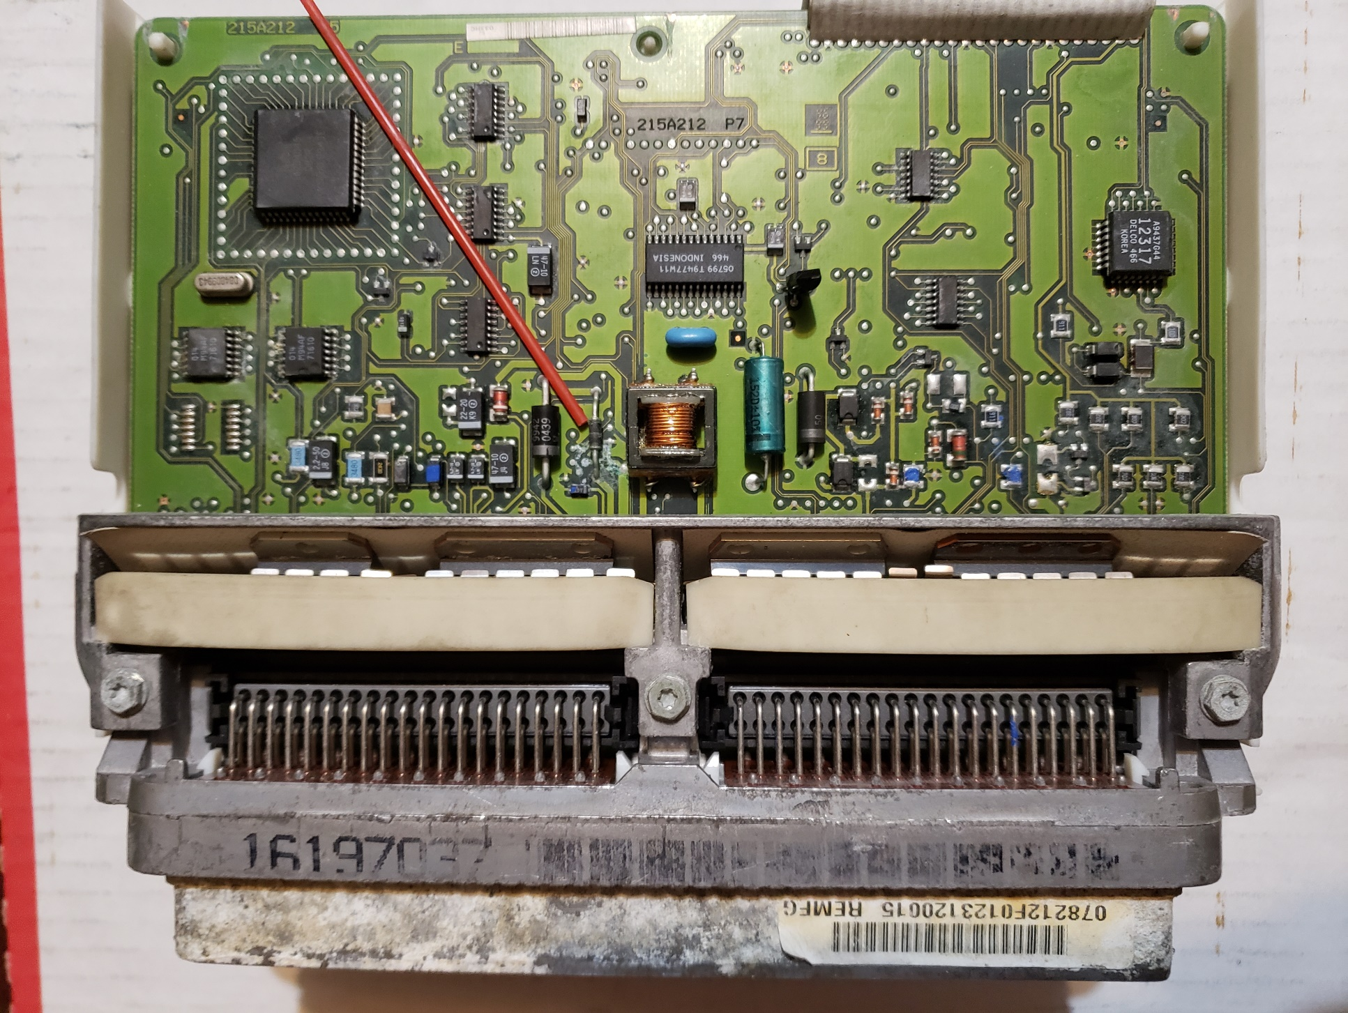

This magnified view really shows the diode with no labeling on it anymore !
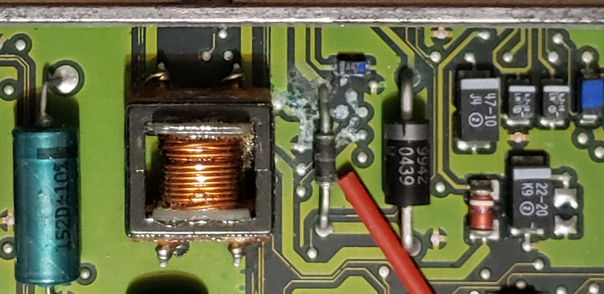

..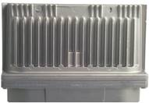 …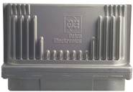.. .. 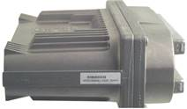 ..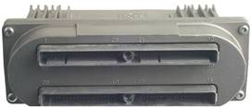..
SAME Part for : 98 Corvette, 98 Camaro, 98 Firebird

